/\* Ashok IPBC Mor.Project R2SP5 Story 8 Lab 8.6.19\*/

Homework:

4. Complete R2:SP5: Story 8 – Create the Loans To Date/ Demographics part of the Dashboard.

Explain the entire process with explanations &amp; screenshots. While everything doesn’t need to

be captured, milestones such as completed queries and reports should be documented.

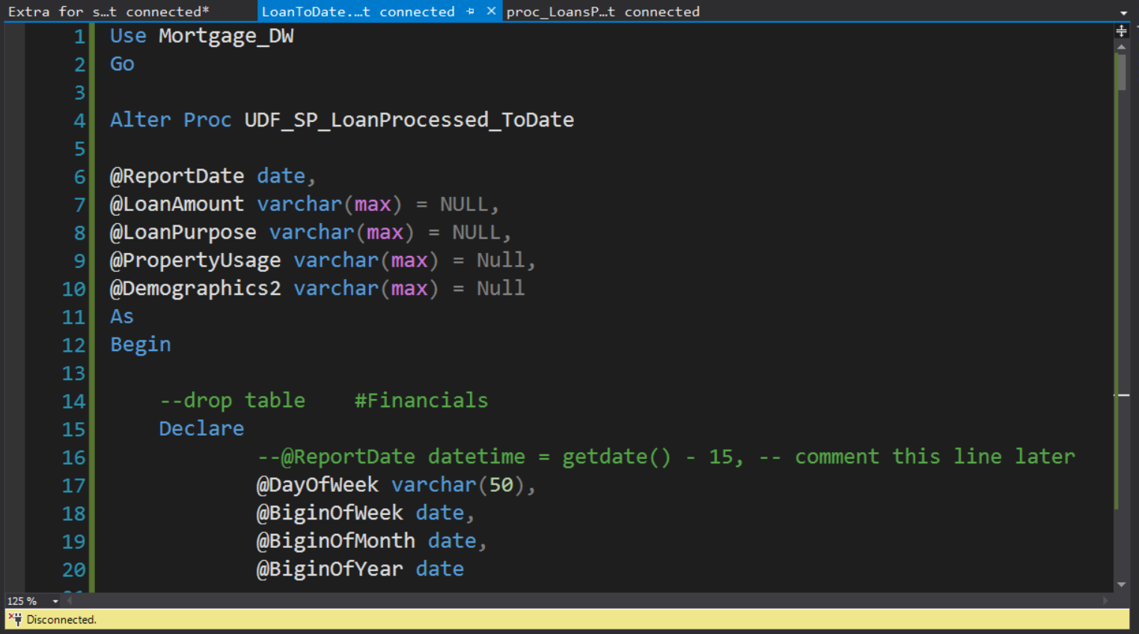

Now we will update our stored procedure for demographics parameter

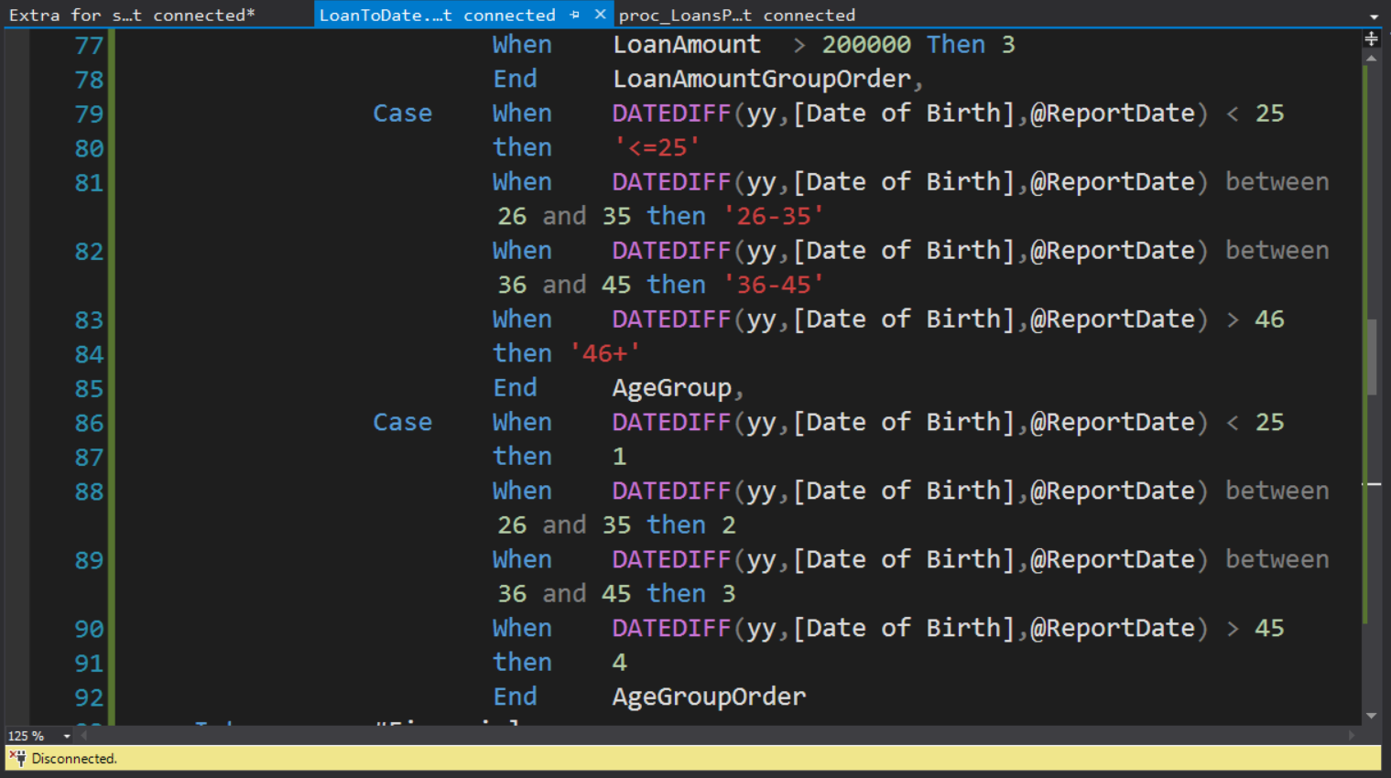

We use datediff function to find the age of customers and set them in different group as shown

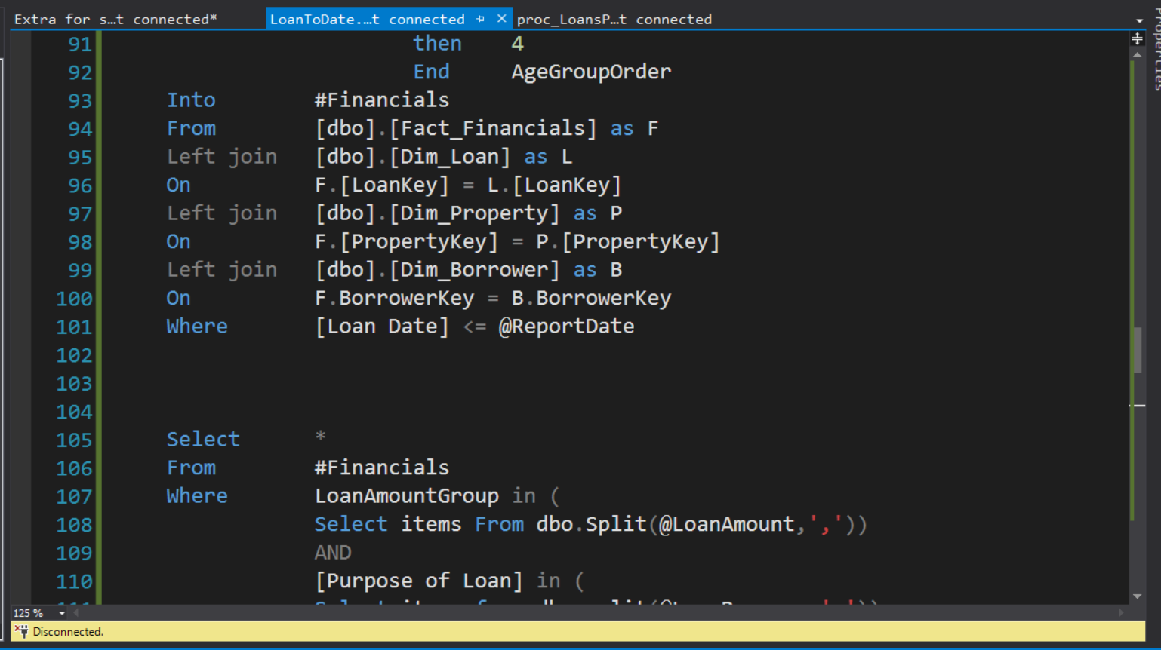

We use left join to join dimensions and facts by their keys

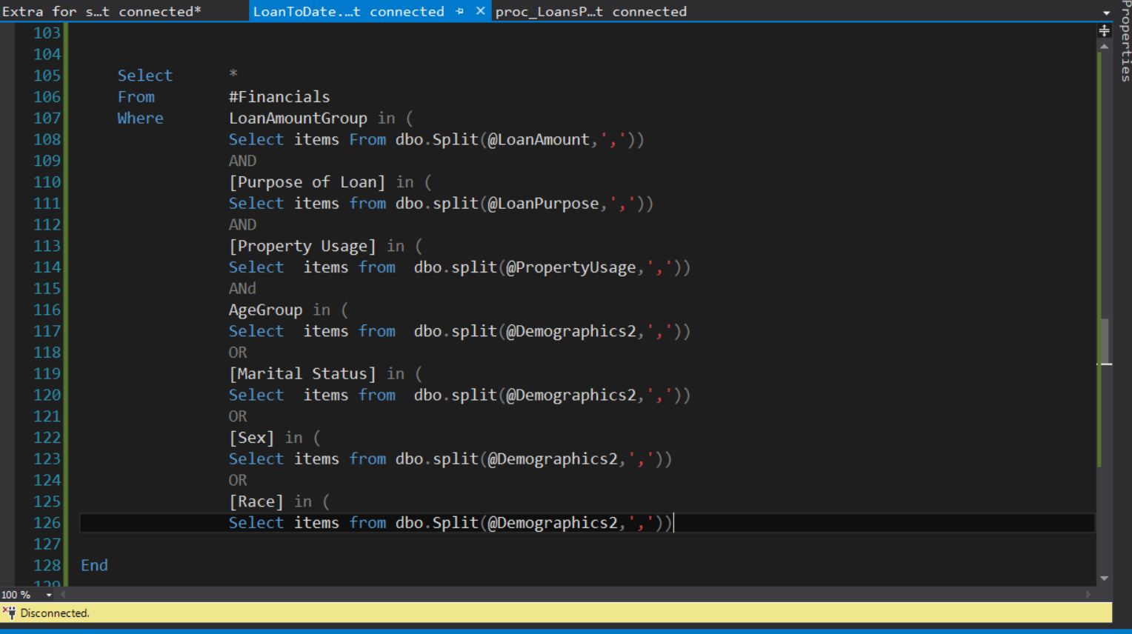

Now we fetch our temporary table which condition as each group marital status race and sex which is received in demographics parameter

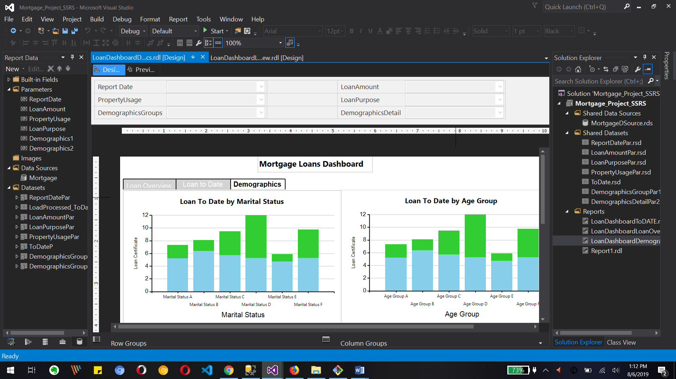

This shows our loan to dashboard demographics report for marital status, age group, race and sex in design view

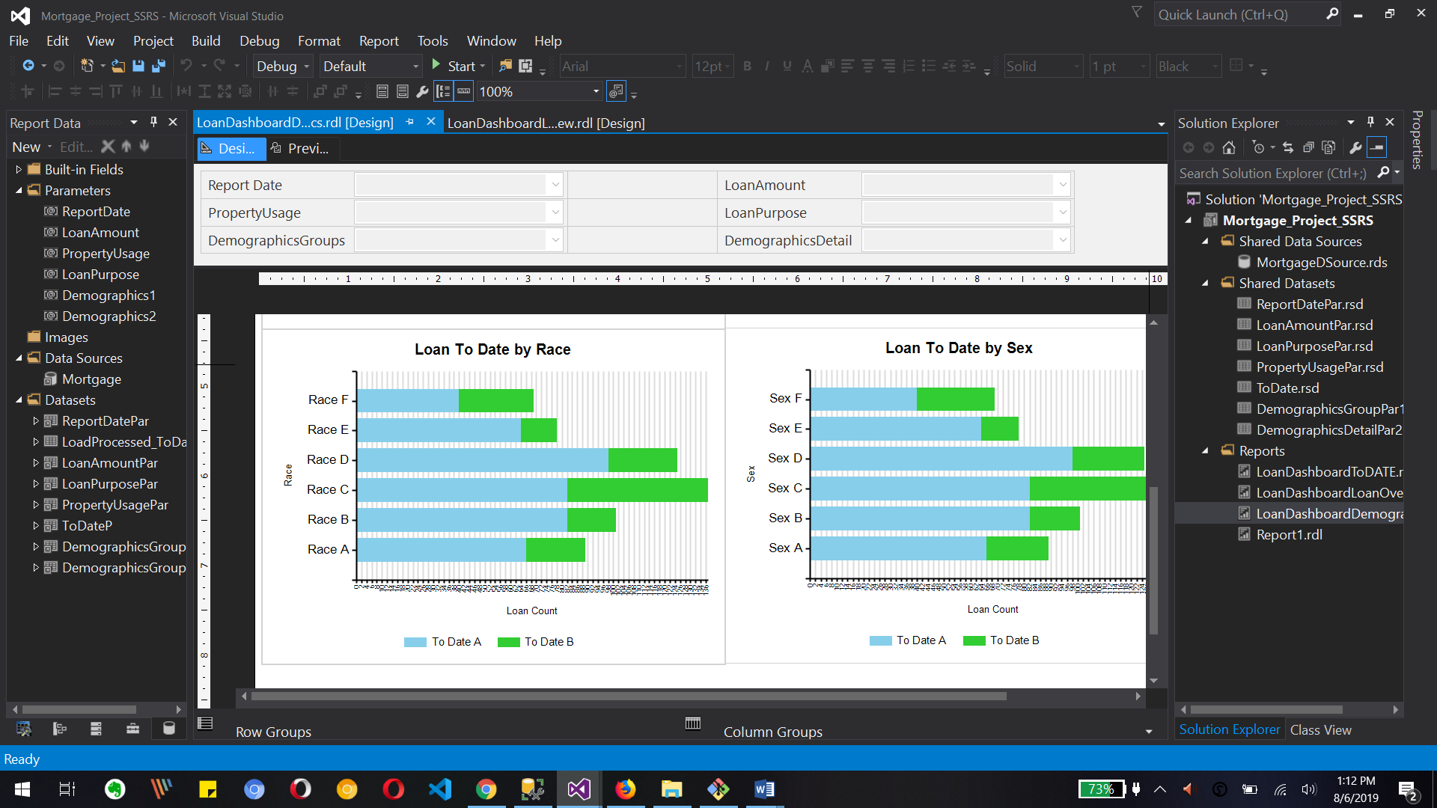

This shows our loan to dashboard demographics report for marital status, age group, race and sex in design view

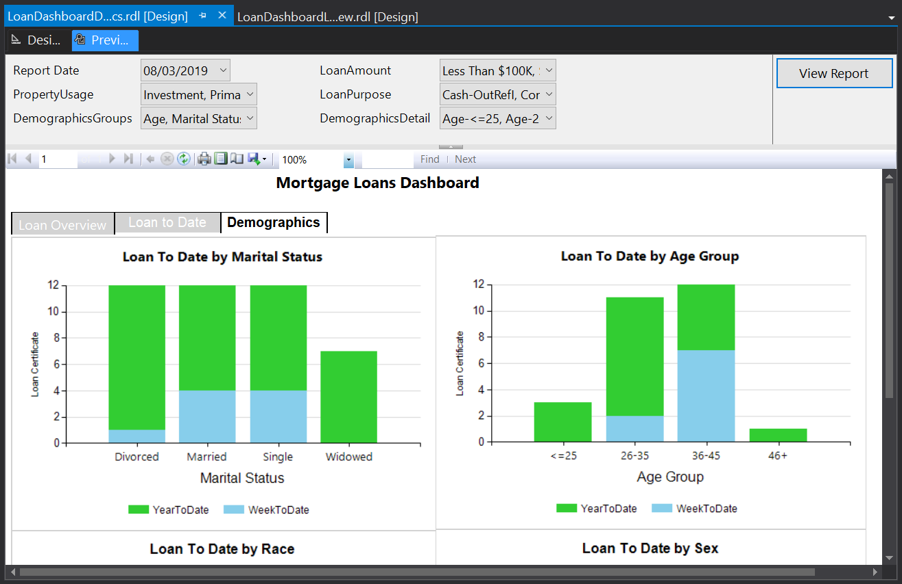

This is review with all selected parameters which are default for by marital status and by age group for loantodate report

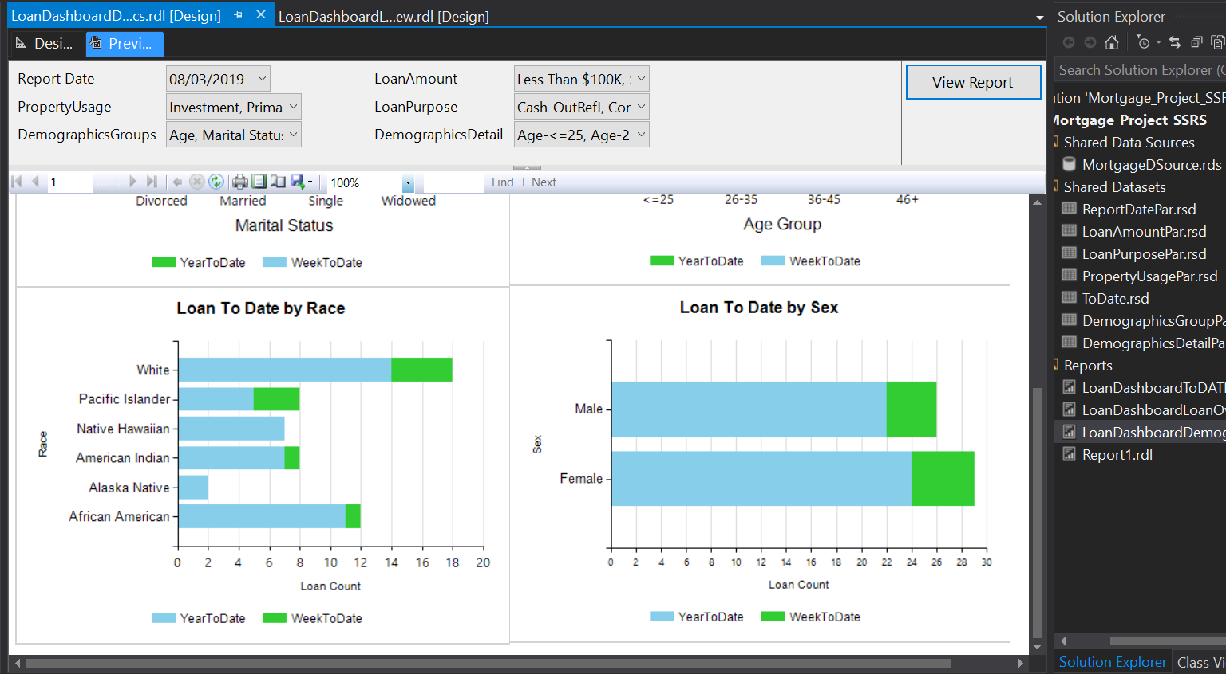

This is review with all selected parameters which are default for by race and by sex for loantodate report

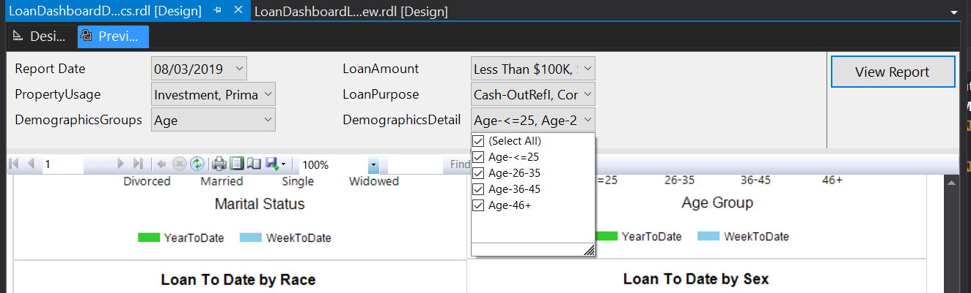

We can see our cascading parameters

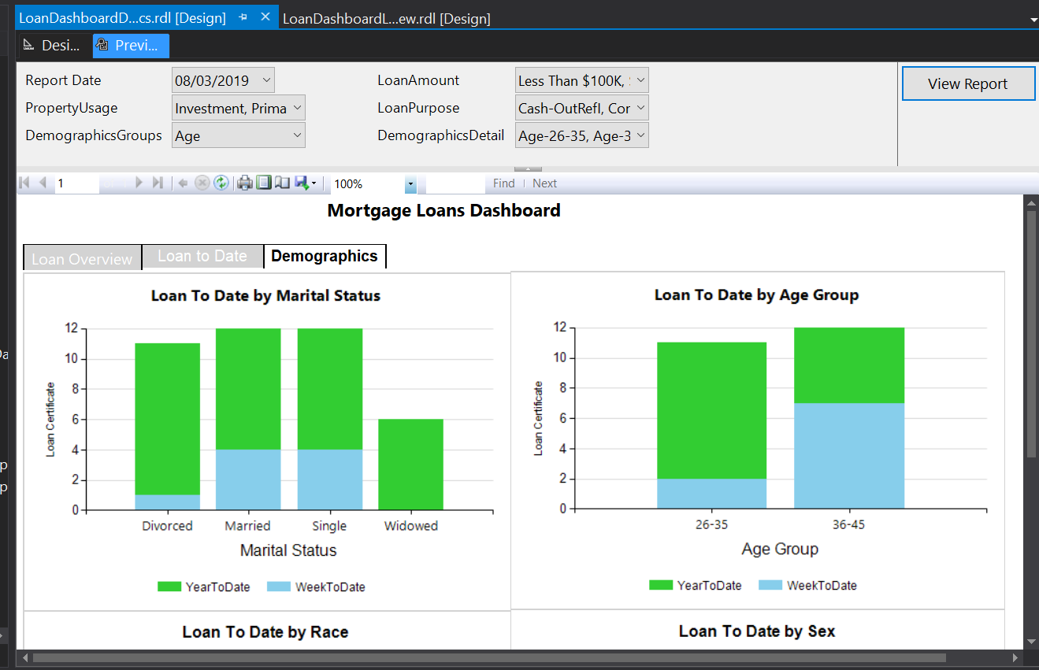

In parameter we selected age as a demographic groups and detail for the age is a 26 to 35 and 36 to 45 so we can see our report for age group for that selected parameters

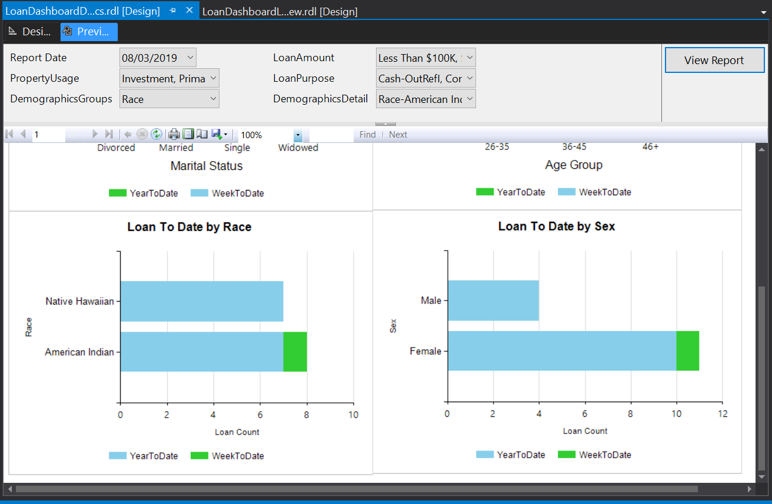

Return the demographic groups parameter to race and also we can see the change in demographic details for American Indian and native Hawaiian and we can see that change in our report lawn to date by race

What to Submit:

1. SQL BI Interview Questions: SSRS - Name 3 of the less common Report Items and how you

used them

<https://app.colaberry.com/app/ipbc/videos?user=31221&category=49>

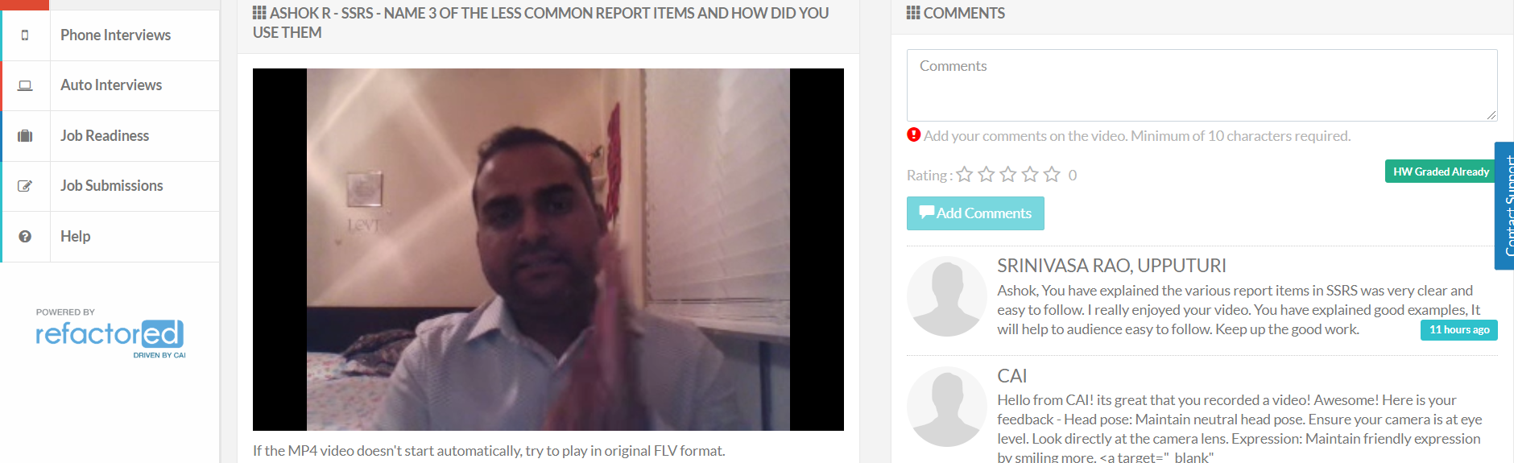

1. SQL BI Interview Questions: SSRS – What is the difference between REPORT MANAGER and

REPORT SERVER

<https://app.colaberry.com/app/ipbc/videos?user=31221&category=47>

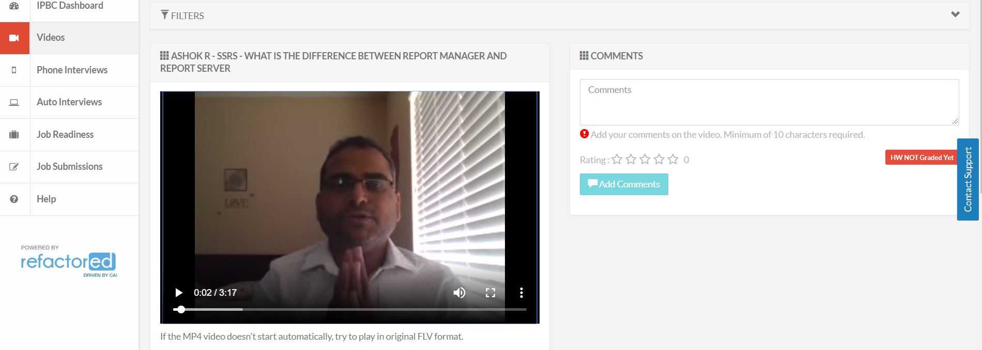

2. Watch, Comment &amp; take screenshots of your comments from 3 other videos on the same

topic (per question). Comments must be 20+ characters. Leave comments based on

presentation, delivery and/or technical details. Your critiques will help you be more

conscious of your own videos. (3 comment screenshots per Video Question)

* Name 3 of the less common Report Items

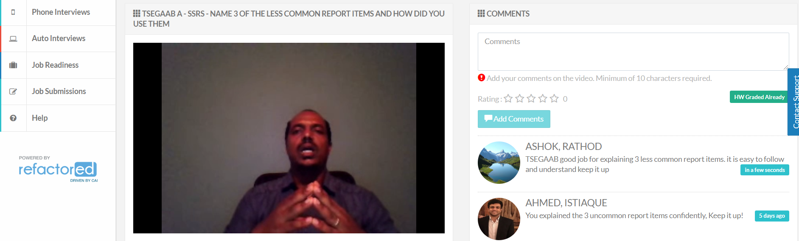

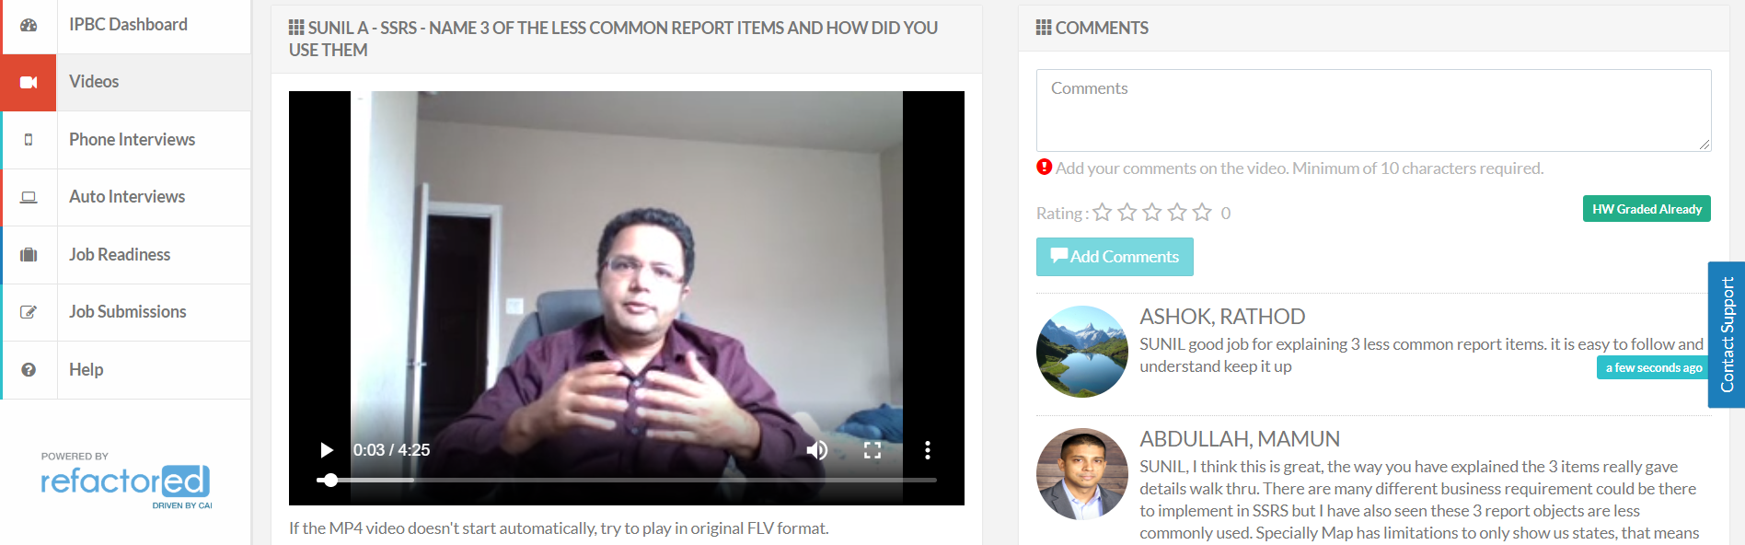

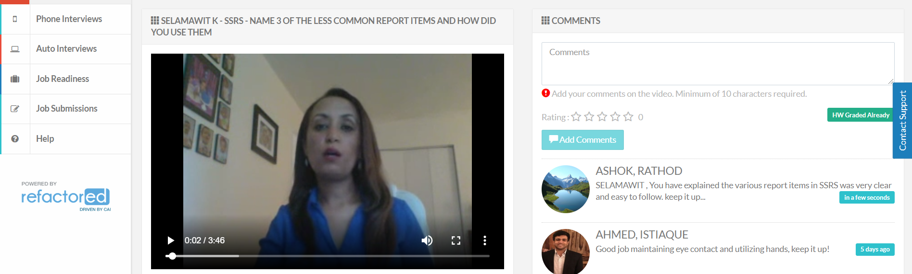

* What is the difference between REPORT MANAGER and REPORT SERVER

